Work Experience: Malvern Priory Window Removal Document

Interpreting the Brief:
The task for this project is to create media content, such as photographs and video, recording the removal of a stained-glass window as well as the stabilisation of the stonework following the removal.
Our Team and Jobs:
- Project Manager – Mark Stanley
Managing the project and everyone who was involved in it.
- Cinematographers – James Preston-Lemon / Ben Clowes
Organising the photography and videography of the project.
- Researchers – Benjamin Chi, James Saunders, Rhys Mitchell-Checketts
Research into the history of the priory as well as the restoration process.
- Web Researcher – Tori Turner
Research into similar projects and how others managed them.
- Digital Marketer – Sam Brighton

- Content Writer – N/A

- Investigation – Alex Van-Schepdael
Investigating the history of the architecture, as well as the techniques, materials and tools used in the construction of the priory.
- Narrator / Presentation – Sam Brighton
Narrating the script made by the content writer for the footage.
My Job Role
The job role that I chose to undertake was the job of the cinematographer. The cinematographer is one of the most important roles for this type of project because they will be handling the filming and photography side of the project. In the client brief, the people at the Malvern Priory specifically asked for the creation of a time lapse film and other media content that would record the removal of the stained-glass window. Therefore, as a cinematographer, I have a huge responsibility to ensure that the media that I create is of a high standard, is relevant to the project and is shared with others within my team.
I chose the role of the cinematographer primarily because I have prior experience in the subject. I did an A-Level in photography and as a result, I have a lot of knowledge that would be useful for a project like this. It also helped that for my A-Level, I bought a lot of expensive equipment that would enable me to take better photos. So from the start, I had a major reason to pursue the photography side of the project. For my A-Level, I made a project surrounding the theme of memories, where I learned a lot about taking photos in low light. Churches are known for having dark or lower lighting conditions, so my prior experience with low light photography would be beneficial for this project.
Resource List
- Camera Body: Canon EOS 4000D
- Standard Zoom Lens: Canon EFS 18-55mm
- Telephoto Zoom Lens: Canon EF 75-300mm
- Large Tripod: Amazon Basics 152cm Tripod with Bag
- Small Flexible Tripod: Lammcou Octopus Flexible Tripod
- Phone: iPhone XR
- Editing Software: Google Snapseed
- PC: Acer Aspire C24
The First Visit to the Priory
On Wednesday 2nd November 2022, I visited the Malvern Priory as part of the project. As I live closer to Malvern than to Worcester, I went straight to the priory instead of coming to the college. Because of this, I arrived approximately a quarter of an hour before the others. I met with one of the people who was going to talk to us about the priory and she took me inside the building. Because of this, I was able to get a preview of the priory, which was advantageous as I was able to get a better feel for the environment that I would be taking photos in. The others arrived shortly after and we were given a tour of the priory.
The people at the priory explained some of the history of the building to me. The priory originated as a Benedictine monastery that was founded in 1085, just after the Norman Conquest of England. For approximately 450 years, it served as a waystation for salt miners operating in the West Midlands region. A stained-glass window called the Magnificat Window, was gifted to the priory by Henry VII in 1501. However, in 1541, Henry VIII passed laws that moved to disband the monasteries of England, including the Malvern Priory. The local people raised £20 to preserve the priory and restore it as the new parish church at the centre of Great Malvern. The priory was further restored in 1840 by Sir George Gilbert Scott and two modern stained-glass windows were created by Thomas Denny in 2004.
The first problem that I was aware of was how the lighting would affect the photos. Having been to religious buildings such as St. David’s Cathedral in Pembrokeshire, I know that they generally make use of low light, with the light that is present being quite subtle. The lighting in the Priory primarily makes use of orange and yellow light, which is done to simulate the warmth of candlelight, used traditionally in holy buildings. There is also light that is cast from stained glass windows but given that the glass window in question has been covered up, I knew it wouldn’t be useful to us. The biggest problem is that cameras try to give a balanced image with an average exposure throughout the photo, so when trying to photograph stained glass, the lighter areas appear very overexposed, and the darker areas appear very underexposed.
After I had been given a tour of the building, Mark Stanley and I went to scout a vantage point that would give us a good view of the area that the stained glass was going to be removed from. We went up onto the right side of the chancel and found a vantage point next to the Knotsford Tomb overlooking the St. Anne’s chapel. This vantage point gave us a perfect view of the stained-glass window, and after testing the vantage point with a couple of practice shots, I knew that it would be the best place to photograph the window. Whilst overlooking the scaffolding surrounding the window, I realised that one of the biggest challenges was going to be getting the details on the window, whilst looking between the bars. This is where I knew my telephoto lens would come in handy, as I knew that it would be able to see the details a lot closer than my regular lens, therefore allowing me to get photographs of the window. I also knew that I would have to be conscious of the people working on removing the window.
To photograph this building, I will use specialist equipment. I own a DSLR camera that can take photographs significantly better than a smartphone camera. I can also set my camera to manual mode, which will allow me to change the settings to adjust to the lighting conditions of the priory. My camera has two lenses: a regular lens and a telephoto lens. My regular lens can capture images up close, while my telephoto lens can be used to take photos from a distance. The advantages of both is that I can get different perspectives of scale with my photos. I also own two tripods: a large one with fixed positions and a small one with flexible legs that allow me to adjust to any position. The advantage of these is that I can stabilise my camera, which is important especially when using the telephoto lens, and I can utilise my camera in multiple vantage points which can allow for a more diverse range of photos.
The Second Visit to the Priory
My second trip to the priory was on Tuesday 8th November 2022. This was going to be the first of several photoshoots that would document the removal of the stained-glass window. I was joined by Mark, our project manager, who was also going to assist with the photoshoot. I brought my equipment, which consisted of my camera body, my regular lens, my telephoto lens and my small stand with the flexible legs. Using this equipment, I went up into the vantage point and started my main photography.
I started photographing the stained-glass window, whilst Mark was capturing an interview of one of the priory staff on video. The workers moving around the site didn’t pose too much of a problem for me, but I knew that I would have to photograph them when they were in a stationary position. I was mostly confined to the space near the vantage point, as that was the best place in the priory to get footage of the window.
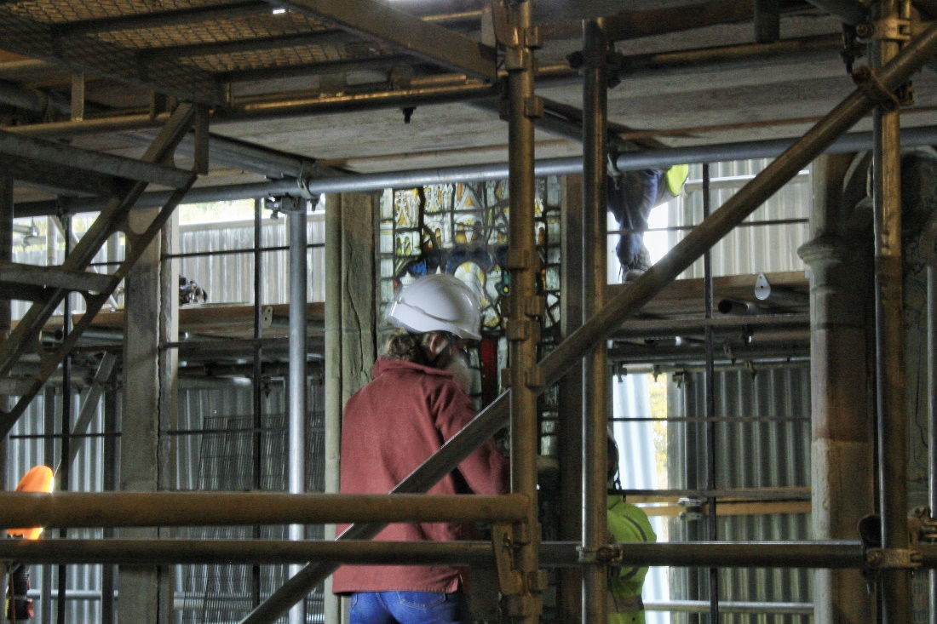
As I suspected, the lighting conditions weren’t optimal for my camera. I took several practice shots, adjusting the shutter speed and the ISO speed, until I got a setting that would be able to work in low light conditions. I set the shutter speed to 1/6 and the ISO speed to 1600, which gave the image a relatively neutral light balance, and that was the best I could do under those conditions. After that, I knew that I would have to improve them in the edit.
The first problem that arose was that my flexible stand wasn’t as useful as I thought it would be. It was able to attach it to the railing around the vantage point, but other than that I could only use my camera for handheld photography. This resulted in several photos, particularly ones taken with the telephoto lens, coming out very blurred and distorted. I was starting to get very annoyed by this problem as usually I’m able to get sharp photos. In the end, only a few of the photos came out looking sharp enough, and I’m not skilled enough at editing to fix the ones that were blurry.
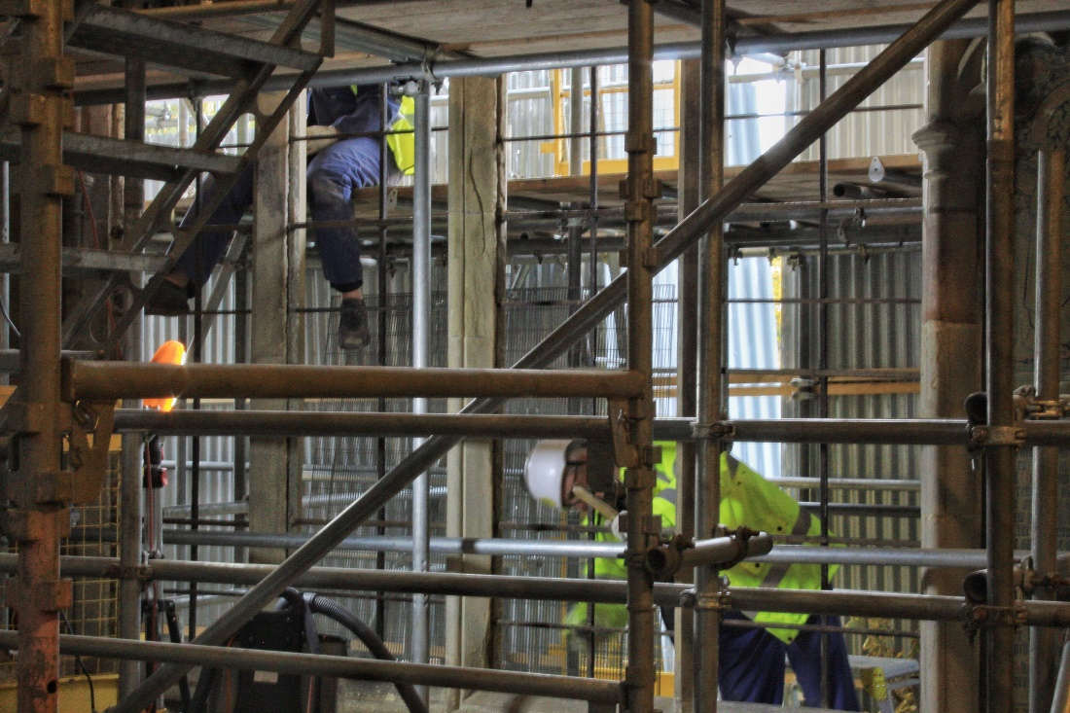
Later, I decided to photograph the site down in the chapel itself. Changing the vantage point meant that I had to change the way I shot the site. I switched to my regular lens, as I was too close to the site to take photos with the telephoto lens.
At the end of the visit, I talked to one of the people at the priory and asked them why the window was being removed. They stated that they weren’t replacing the stained-glass window, instead they were replacing the outer layer of the window. She explained that the window was built with a protective layer on the outside of the church, which keeps the stained-glass safe from adverse weather conditions such as rain. They explained that earlier this year, they discovered a problem that a large amount of moisture had built up in the seam between the stained-glass and the protective layer, which was slowly rotting the protective layer. The priory raised approximately £132,000 from several benefactors, including grants from the Headley Trust, the Worshipful Company of Glaziers and the painters of Glass, as well as several anonymous donors. The priory are removing the protective layer and replacing it with a more environmentally friendly version that is meant to be more protective as well as last longer.
At the end of the hour, I had a chat with the lady who was escorting us around the priory, where I learned that there would be a better opportunity to get photos. I learned that the stained-glass window was set to be removed on the Thursday and that the rest of the work would continue after that. I knew that if we wanted the best photos of the window removal that we would have to go on the Thursday to get the extra photos. However, Mark and the others couldn’t come that morning due to living further away from Malvern. As a result, I volunteered to go and photograph the window’s removal on Thursday. Not only would this allow me to witness the event of the window’s removal, but also allow me to get more photos using my larger stand.
The Third Visit to the Priory
On Thursday 10th November 2022, I went to the priory a third time for additional photography. This was the day that the stained-glass window was going to be removed, which would mean that I would be able to get photos of the glass’s removal. After going through the photos that I had taken before, I realised that I needed to use my large tripod for the next photoshoot. I wanted to use it because I realised that I would be able to get more photos that didn’t suffer from blur, and therefore I would be able to use more of them.
I arrived at the priory at 9:30, and I knew that I could only be there for approximately an hour. I came alone this time, because I was the only person who could get to the priory within the limited time frame, as well as the only person with the equipment capable of getting high quality photos. Because I was using the larger tripod, I was going to have to be more conscious of the space than I had before. This made my job a lot more difficult because the space surrounding the vantage point was quite closed off. I managed to work around it by adjusting the tripod into a narrow position, but it meant that I could only take photos from one orientation, which is why all the photos seem to be taken at the same angle. Once I had set up properly, I adjusted by camera to the settings that I used before and started taking photos.
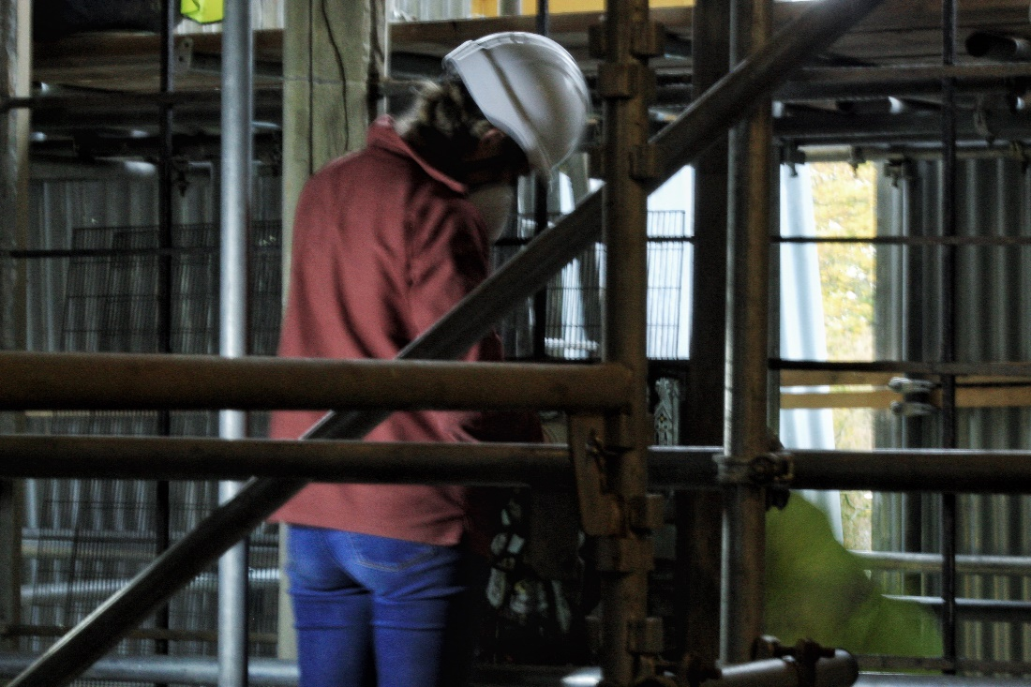
One thing that I noticed is that by using the larger tripod, I got photos of a significantly higher quality. The blur became very minimal, but there was still a number of photos that didn’t come out great. Nevertheless, the quality improved drastically, and I found myself being more proud of the photos I had taken. On that day, I noticed that there was significantly more light being cast through the stained-glass window than on the previous times I had gone to the priory. My camera was adjusting to the light conditions more naturally this time around, and I think that the brighter lighting played a large part in that.
However, the extra light resulted in a number of complications. Whilst the people were removing the window, the light was reflecting off the edges of the glass and reflecting directly into my camera lens. This appeared in several of the photos as lens flares; an effect where the light becomes scattered and reduces the colour saturation and contrast, making the affected area appear to be washed out. This was a particularly annoying problem because I couldn’t edit the image to get rid of them or make them less intrusive. This is a camera’s natural response to bright light and if I tried to decrease the exposure, it would result in inconsistent light levels.
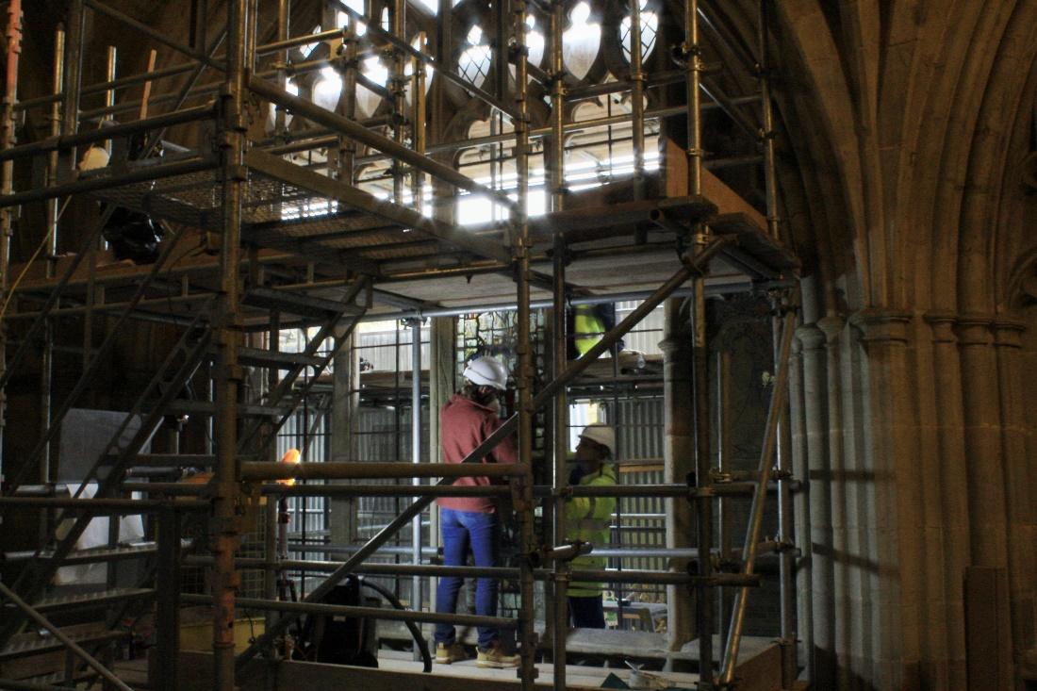
An example of one of the photos that experienced lens flares. As you can see in the top of the window, the light is “bleeding” from the edges, affecting the contrast of the image.
Nevertheless, the final photoshoot was the most successful one yet. I managed to get photos of the people working on the window’s removal. One of the last photos I took was of the stained-glass window finally out of the frame. One of the people working on it volunteered to hold it up for me, whilst I was taking the photo. Here is the edited result:
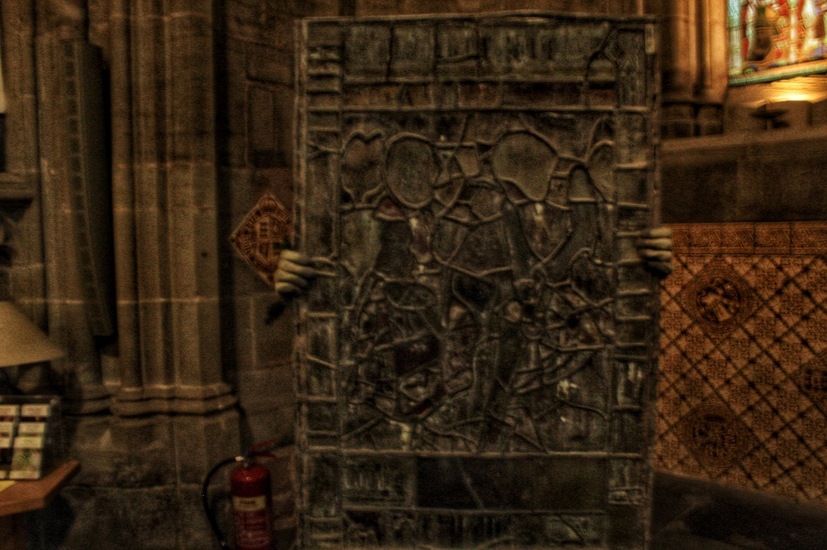

Also, after capturing photos of the stained glass, I managed to get some photos of other parts of the priory, including one of the other chapels. Though many of these photos didn’t turn out so well, this one came out particularly beautiful:
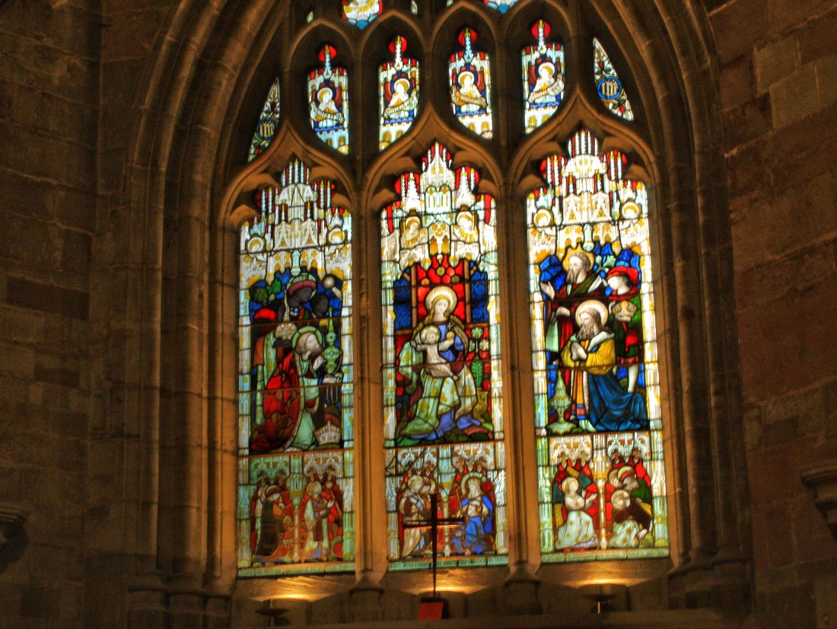
This was the last photo I took at the priory before I left. I decided that the ones that I took were sufficient enough for the project so I wouldn’t need to the priory again. I didn’t want to go again because I felt that I wouldn’t be photographing anything new and it would therefore be an unnecessary shoot. The photos I had taken were able to show the scope of the project as well as the major developments.
Editing the Photographs:
After my third visit, I went home and edited 6 photos (the images shown in the previous paragraphs). Editing is extremely important as it helps to make the photograph more visually appealing, adds a level of artistry to it and fixes certain issues with the original image. However, editing photos isn’t easy, as it requires a lot of attention to detail to get the image looking just right. Sometimes, after editing the photo the first time, you notice issues that have become more obvious because of the editing, forcing you to do re-edits. This process requires a lot of trial and error, and because of this it can take quite a long time. However, I am fairly experienced in this and I have a specific method for editing photos that I learned back in my photography course at high school.
The first thing I do is adjust the structure and the sharpness of the image. This helps to give more definition to the image, assuring that every element within the frame is visible. The next thing I did was use the tuning tool to tune aspects of the image. I adjusted the brightness of the image. This was especially important in these because of the low lighting in the priory, meaning that most of the images were quite dark. After that, I adjusted the colour saturation of the photos. This is what gives images richer and more vivid colours, which I thought was pertinent to the windows, allowing their colours to look more dynamic. I then adjusted the ambiance of the photos. This helps to control the light balance of the photo, meaning that one area isn’t more exposed than the rest. I then tuned the highlights of the image, which helps to either intensify or reduce the strength of the lightest areas of the photo. I then turned the shadows, which helps to either intensify or reduce the strength of the darkest areas of the image. In both stages, I was trying to decrease their strength in order to get a better light balance. The last stage is adjusting the warmth of the image, which adjusts the spectrum of red, orange and yellow tones of an image that can help establish the mood of the photo. In the case of these photos, I wanted my photos to reflect the orange candlelight within the priory, so the photos look a lot warmer than a regular photo.
However, this wasn’t the end. Whilst going back through some of the photos, I felt that they still didn’t look right and that I would need to further tune some of the details. To do this, I decided to break out the Brush tool. This tool allows me to manually highlight a certain area of the image and tune that certain area. For example, on the coloured stained-glass windows, I used the brush tool to further increase the colour saturation of the coloured windows, making them more distinct and vivid apart from the rest of the image. The difference between the tuning tool and the brush tool is that the tuning tool changes the effect for the entire image, whilst the brush tool only affects a highlighted area of the image. A common issue was that the light coming from the stained-glass windows was very strong, looking over-exposed and throwing off the light balance. To counter this issue, I used the brush tool to further lower the exposure of the light around the windows. In the end, the images came out with relatively balanced lighting and no problems with exposure.
Feasibility:
The last part of the project that I want to talk about is the feasibility of the project. Because the main aim of our project was to document the removal of the window on video and in photos, we didn’t have much input on the removal of the window itself. The only aspect I can think of where we did have some impact is that one of the people working on the window’s removal held up the window so that I could take a photograph of it. Other than that, it was more the case that we had to work around their schedule, so that they could get on with the window’s removal mostly uninterrupted. The advantage of this is that both parties were mostly left to sort out their work on their own. The disadvantage of this is that it limited our ability to get photographs and video, because we had to be conscious of the work that was currently going on. We managed to work around this by getting photos during interim periods when the people weren’t working on the window. An example of this was when Mark got on the scaffolding to get his own footage.
When I was doing my research, I noticed that the priory website doesn’t include a dedicated images page, which led me to wonder where the images would be displayed on the website. After taking another look on the website, I realised that they would place them in the News from the Priory blog, where they post updates and events concerning the priory. They also have two social media accounts on FaceBook and Instagram, where they could post the images for viewers to see. However, they have no videos on their website so I assume they would put that with the photos in the blog post or on their social media accounts.
Conclusion
With this project, I believe that I have taken photos of a great quality that will show the renovations done to the Malvern priory. I wanted to make my photos stylised so that they would look more interesting to average viewers, which is why the colours have been made brighter on some of the photos.

